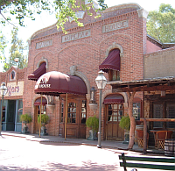 | 2016 Annual Scholarship Fundraiser  SPONSOR REGISTRATION FORM  Saturday, October 22 6:30 PM to 9:30+ PM  SAVOY OPERA HOUSE in TRAIL DUST TOWN  6541 E. Tanque Verde Tucson, Arizona  Live music by the Clear Country Band  Western Attire – Put on Your Best Boots & Let’s Kick the Dust Up!
Sponsorship packages
SELECT ONE | LEVEL | AMOUNT | DINNER TICKETS | NAMED SCHOLARSHIP (1 YEAR) | NEWS RELEASE | DINNER MEETING BANNER (1 YEAR) | SME TUCSON WEB PAGE ANNOUNCEMENT | EVENT SIGNAGE
 | Mother Lode | $5,000.00 + | 12 |  |  | + | + | +
 | Bonanza | $3,000.00 | 8 |  |  | + | + | +
 | Big Nugget | $2,000.00 | 8 |  |  | + | + | +
 | Pay Dirt | $1,000.00 | 6 |  |  | + | + | +
 | Prospect | $500.00 | 4
 | Supporter | $_______ | 0
+ Signifies company logo is Included in this portion of the package. If there is no +, your company name will be in text.
Please email your 300 dpi color logo to smetucson@gmail.com prior to October 3rd (png, tif or jpg). Logos will be printed as provided.
Sponsor contact information
Sponsor Name (as it is to appear in announcements):
Contact Full Name: Title:
Contact Primary Phone: Contact Alternate Phone:
Email: Dept:
Mailing Address:
City: State: Zip:
Payment: Online, Date: By Check, Check Number:
Sponsor dinner selections
DINNER RSVPS: Sponsors can RSVP for dinner tickets and make entrée selections online at our Eventbrite page. Beginning in 2016, sponsors must utilize a promotional code to access and reserve complimentary dinners. Upon receipt of this form, the sponsor contact (as completed above) will be emailed with the corresponding promotional code. Go onto the Eventbrite page and click “Enter promotional code” to make your reservations.
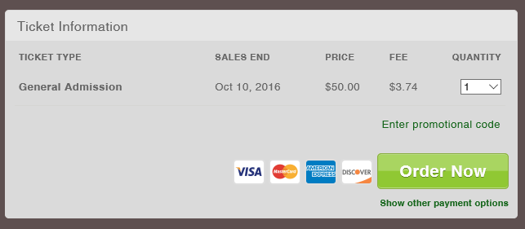

EXTRA GUESTS: If you elect to bring more guests than are included in your sponsorship package, you may register them by going online to our Eventbrite page. Each additional dinner is $53.74. The more the merrier!

UNREGISTERED DINNERS: If we do not receive RSVPs for your organization by Monday, October 10th, any dinners not utilized will be donated to students. Please be aware only those dinners actually reserved will be prepared, not the total number of tickets which come with your sponsorship. This is because SME must pay the Savoy Opera House for every meal they serve. If you know you will be bringing someone but are not certain whom, please RSVP with “GUEST” and our Board will follow up for specifics. We greatly appreciate your assistance and understanding! Additionally, any dinners reserved without a meal selection will default to beef entrée choice.
Deadlines & Payments
- SPONSOR DEADLINE: Monday, October 3rd, to receive all sponsor benefits
- DINNER TICKET DEADLINE: Monday, October 10th
- PAY BY CHECK: Mail this form along with your check made payable to SME TUCSON SECTION to:
SME Tucson Section, PO Box 30456 Tucson, AZ 85715
- PAY ONLINE: Pay for your sponsorship online at www.smetucson.org/sponsor then email this form to
smetucson@gmail.com

